PRACTICAL FILE
Information and Image Retrieval

Parth Singh Tanwar
22058570021
BSc. (Hons) Computer Science
Sem – 8

Q1. Write a program to compute the edit distance between strings s1 and s2. (Hint.
Levenshtein Distance).

def levenshteinRecursive(str1, str2, m, n):
#checking is strings are empty
if m == 0:
return n

if n == 0:
return m
if str1[m - 1] == str2[n - 1]:
return levenshteinRecursive(str1, str2, m - 1, n - 1)
return min(

1+levenshteinRecursive(str1, str2, m, n - 1),
1+levenshteinRecursive(str1, str2, m - 1, n),
2+levenshteinRecursive(str1, str2, m - 1, n - 1)
)

#Drivers code
str1 = "situation"
str2 = "incantation"
distance = levenshteinRecursive(str1, str2, len(str1), len(str2))
print("Levenshtein Distance:", distance)



Q2. Write a program to Compute Similarity between two text documents.

from sklearn.feature_extraction.text import TfidfVectorizer
from sklearn.metrics.pairwise import cosine_similarity

# Two trial sentences
sentence1 = "India’s journey of development since gaining independence in 1947 reflects determination, change, and ambition. From being primarily an agricultural nation, India has grown into one of the leading economies in the world. The development process has included economic expansion, social improvement, technological growth, and increasing global presence."
sentence2 = "India's development journey since independence in 1947 has been a story of resilience, transformation, and aspiration. From a largely agrarian economy, India has evolved into one of the fastest-growing major economies in the world. The process of development in India has involved economic growth, social progress, technological advancement, and global integration.."

# Create a list of sentences
sentences = [sentence1, sentence2]

# Convert sentences into TF-IDF vectors
vectorizer = TfidfVectorizer()
tfidf_matrix = vectorizer.fit_transform(sentences)

# Compute cosine similarity
similarity = cosine_similarity(tfidf_matrix[0:1], tfidf_matrix[1:2])

print("Sentence 1:", sentence1)
print("Sentence 2:", sentence2)
print("Cosine Similarity:", similarity[0][0])

Q3. Write a program for Pre-processing of a Text Document: stop word removal.

import nltk
import string
from nltk.corpus import stopwords
from nltk.tokenize import RegexpTokenizer

nltk.download('punkt')
nltk.download('stopwords')

text = "I tried so hard, and got so far but, in the end it doesn't even matter!!"

text = text.lower()

text = text.translate(str.maketrans('', '', string.punctuation))

tokenizer = RegexpTokenizer(r'\w+') #tokenizing words using alphanumeric characters
words = tokenizer.tokenize(text)

stop_words = set(stopwords.words('english'))
filtered_words = [word for word in words if word not in stop_words]

print("Original Text:\n", text)
print("\nAfter Stop Word Removal:\n", " ".join(filtered_words))

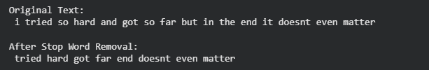

Q4. Consider 3 documents as below:-
Doc 1: Ben studies about computers in Computer Lab.
Doc 2: Steve teaches at Brown University.
Doc 3: Data Scientists work on large datasets.
Perform search on these documents with the following query: Data Scientists and, calculate tf * idf for data and Scientists in all the documents.

import math
from collections import Counter

# Documents
docs = [
"Ben studies about computers in Computer Lab.",
"Steve teaches at Brown University.",
"Data Scientists work on large datasets."
]

# Query terms
terms = ["data", "scientists"]

# Preprocess documents (lowercase + simple tokenization)
processed_docs = [doc.lower().replace(".", "").split() for doc in docs]

N = len(processed_docs)

# Step 1: Compute Document Frequency (DF)
df = {}
for term in terms:
df[term] = sum(1 for doc in processed_docs if term in doc)

# Step 2: Compute IDF
idf = {}
for term in terms:
if df[term] > 0:
idf[term] = math.log(N / df[term])
else:
idf[term] = 0

# Step 3: Compute TF and TF-IDF
for i, doc in enumerate(processed_docs):
print(f"\nDocument {i+1}:")
term_counts = Counter(doc)
total_terms = len(doc)

for term in terms:
tf = term_counts[term] / total_terms # normalized TF
tf_idf = tf * idf[term]
print(f" {term}: TF = {tf:.3f}, IDF = {idf[term]:.3f}, TF-IDF = {tf_idf:.3f}")

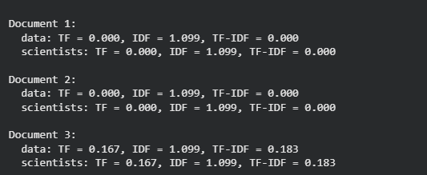

Q5. Write a program to find out the similarity between document d1 and d2 (refer question#4 ) using cosine similarity method.

from docx import Document
from sklearn.feature_extraction.text import TfidfVectorizer
from sklearn.metrics.pairwise import cosine_similarity
import matplotlib.pyplot as plt
import numpy as np

# File paths
doc1_path = "/content/drive/MyDrive/India_Development_Essay_1.docx"
doc2_path = "/content/drive/MyDrive/India_Development_Essay_2.docx"

# Read docx
def read_docx(file_path):
doc = Document(file_path)
return " ".join([p.text for p in doc.paragraphs])

text1 = read_docx(doc1_path)
text2 = read_docx(doc2_path)

documents = [text1, text2]

# TF-IDF
vectorizer = TfidfVectorizer(stop_words='english')
tfidf_matrix = vectorizer.fit_transform(documents)

# Cosine similarity matrix
cosine_matrix = cosine_similarity(tfidf_matrix)

print("Cosine Similarity Matrix:\n", cosine_matrix)

# ------------------ 1. BAR GRAPH ------------------
plt.figure()
plt.bar(["Doc1 vs Doc2"], [cosine_matrix[0][1]])
plt.xlabel("Comparison")
plt.ylabel("Similarity")
plt.title("Cosine Similarity Comparison")
plt.ylim(0, 1)
plt.show()

# ------------------ 2. HEATMAP ------------------
plt.figure()
plt.imshow(cosine_matrix)
plt.xticks([0,1], ["Doc1","Doc2"])
plt.yticks([0,1], ["Doc1","Doc2"])
plt.title("Cosine Similarity Matrix")
plt.colorbar()
plt.show()

# ------------------ 3. WORD VECTOR GRAPH ------------------
feature_names = vectorizer.get_feature_names_out()
dense = tfidf_matrix.toarray()

# top 10 important words
importance = np.sum(dense, axis=0)
top_idx = np.argsort(importance)[-10:]

words = feature_names[top_idx]

doc1_vals = dense[0][top_idx]
doc2_vals = dense[1][top_idx]

x = np.arange(len(words))

plt.figure()
plt.plot(x, doc1_vals, marker='o', label='Doc1')
plt.plot(x, doc2_vals, marker='o', label='Doc2')
plt.xticks(x, words, rotation=45)
plt.xlabel("Words")
plt.ylabel("TF-IDF Score")
plt.title("Two Document Comparison")
plt.legend()
plt.show()

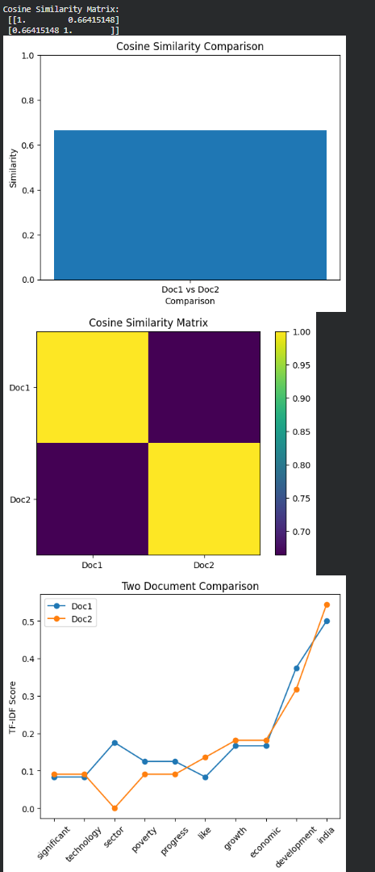
Q6. Write a program to calculate the color moments, color histogram, color coherence vector (CCV), color correlogram for an image.

import cv2
import numpy as np
from collections import defaultdict

# Load image
image = cv2.imread("image1.jpg")
image = cv2.resize(image, (256, 256)) # normalize size

# Convert to RGB
image_rgb = cv2.cvtColor(image, cv2.COLOR_BGR2RGB)

def color_moments(img):
moments = []
for i in range(3): # R, G, B channels
channel = img[:, :, i]
mean = np.mean(channel)
std = np.std(channel)
skewness = np.mean((channel - mean) ** 3) ** (1/3)
moments.extend([mean, std, skewness])
return moments

def color_histogram(img, bins=8):
hist = []
for i in range(3):
h = cv2.calcHist([img], [i], None, [bins], [0, 256])
hist.extend(h.flatten())
hist = np.array(hist)
hist /= hist.sum()
return hist

def compute_ccv(img, threshold=100):
# Quantize colors
quantized = (img // 64).astype(np.int32) # 4 bins per channel
labels = quantized[:, :, 0]*16 + quantized[:, :, 1]*4 + quantized[:, :, 2]

visited = np.zeros(labels.shape, dtype=bool)
ccv = defaultdict(lambda: [0, 0]) # [coherent, incoherent]

def dfs(x, y, color):
stack = [(x, y)]
pixels = []

while stack:
i, j = stack.pop()
if (i < 0 or i >= labels.shape[0] or
j < 0 or j >= labels.shape[1] or
visited[i, j] or labels[i, j] != color):
continue

visited[i, j] = True
pixels.append((i, j))

for dx, dy in [(-1,0),(1,0),(0,-1),(0,1)]:
stack.append((i+dx, j+dy))

return pixels

for i in range(labels.shape[0]):
for j in range(labels.shape[1]):
if not visited[i, j]:
color = labels[i, j]
component = dfs(i, j, color)
if len(component) >= threshold:
ccv[color][0] += len(component)
else:
ccv[color][1] += len(component)

return dict(ccv)

def color_correlogram(img, distance=1):
quantized = (img // 64).astype(np.int32)
h, w, _ = quantized.shape
correlogram = defaultdict(int)

for i in range(h):
for j in range(w):
color1 = tuple(quantized[i, j])

for dx in [-distance, 0, distance]:
for dy in [-distance, 0, distance]:
ni, nj = i + dx, j + dy
if (0 <= ni < h and 0 <= nj < w and (dx != 0 or dy != 0)):
color2 = tuple(quantized[ni, nj])
correlogram[(color1, color2)] += 1

return dict(correlogram)

moments = color_moments(image_rgb)
histogram = color_histogram(image_rgb)
ccv = compute_ccv(image_rgb)
correlogram = color_correlogram(image_rgb)

print("Color Moments:\n", moments)
print("\nColor Histogram:\n", histogram[:10], "...") # preview
print("\nCCV (sample):\n", dict(list(ccv.items())[:5]))
print("\nCorrelogram (sample):\n", dict(list(correlogram.items())[:5]))

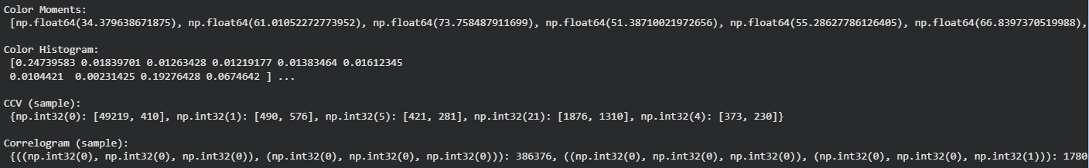

Q7. Write a program to find out the similarity between two images using:-
- Minkowski-form distance

import numpy as np
import matplotlib.pyplot as plt
from PIL import Image
from google.colab import files
import requests
from io import BytesIO

def load_image(source, target_size=(128, 128)):
"""
Load an image from file path or URL and resize it.
"""
if source.startswith('http'):
response = requests.get(source)
img = Image.open(BytesIO(response.content))
else:
img = Image.open(source)

# Convert to RGB if necessary
if img.mode != 'RGB':
img = img.convert('RGB')

# Resize for consistent comparison
img = img.resize(target_size)
return img

def image_to_vector(img):
"""
Convert PIL Image to a normalized 1D numpy array.
"""
arr = np.array(img, dtype=np.float64)
# Normalize pixel values to [0, 1]
arr = arr / 255.0
# Flatten to 1D vector
return arr.flatten()

def minkowski_distance(vec1, vec2, p=2):
"""
Calculate Minkowski distance between two vectors.

Parameters:
- vec1, vec2: Input vectors (must be same length)
- p: Order of the Minkowski distance
- p=1: Manhattan distance (L1)
- p=2: Euclidean distance (L2)
- p=∞: Chebyshev distance (use p='inf' or np.inf)

Formula: D = (Σ|x_i - y_i|^p)^(1/p)
"""
if p == 'inf' or p == np.inf:
return np.max(np.abs(vec1 - vec2))

diff = np.abs(vec1 - vec2)
return np.power(np.sum(np.power(diff, p)), 1/p)

def similarity_from_distance(distance, max_distance):
"""
Convert distance to similarity score (0 to 1).
Higher score = more similar.
"""
return 1 - (distance / max_distance)

def compare_images(img1, img2, p_values=[1, 2, 3, np.inf]):
"""
Compare two images using various Minkowski distances.
"""
vec1 = image_to_vector(img1)
vec2 = image_to_vector(img2)

n = len(vec1)

results = {}

for p in p_values:
distance = minkowski_distance(vec1, vec2, p)

# Calculate theoretical max distance for normalization
if p == np.inf or p == 'inf':
max_dist = 1.0 # Max single element difference
p_name = "∞ (Chebyshev)"
else:
max_dist = np.power(n, 1/p) # All elements differ by 1
p_name = str(p)
if p == 1:
p_name = "1 (Manhattan)"
elif p == 2:
p_name = "2 (Euclidean)"

similarity = similarity_from_distance(distance, max_dist)

results[p_name] = {
'distance': distance,
'similarity': similarity * 100 # As percentage
}

return results

def display_results(img1, img2, results):
"""
Display images side by side with similarity results.
"""
fig, axes = plt.subplots(1, 3, figsize=(14, 5))

# Display images
axes[0].imshow(img1)
axes[0].set_title('Image 1', fontsize=12)
axes[0].axis('off')

axes[1].imshow(img2)
axes[1].set_title('Image 2', fontsize=12)
axes[1].axis('off')

# Display results as text
axes[2].axis('off')

text = "Minkowski Distance Results\n" + "=" * 30 + "\n\n"
for p_name, data in results.items():
text += f"p = {p_name}\n"
text += f" Distance: {data['distance']:.4f}\n"
text += f" Similarity: {data['similarity']:.2f}%\n\n"

axes[2].text(0.1, 0.9, text, transform=axes[2].transAxes,
fontsize=11, verticalalignment='top',
fontfamily='monospace',
bbox=dict(boxstyle='round', facecolor='wheat', alpha=0.5))

plt.tight_layout()
plt.show()

print("=" * 50)
print("Image Similarity using Minkowski Distance")
print("=" * 50)

def create_sample_images():
"""Create simple test images."""
img1 = np.zeros((128, 128, 3), dtype=np.uint8)
for i in range(128):
for j in range(128):
img1[i, j] = [200 - i//2, 50 + j//2, 100]

img2 = np.zeros((128, 128, 3), dtype=np.uint8)
for i in range(128):
for j in range(128):
img2[i, j] = [180 - i//2, 70 + j//2, 120]

img3 = np.zeros((128, 128, 3), dtype=np.uint8)
for i in range(128):
for j in range(128):
img3[i, j] = [50, 100 + i//2, 200 - j//2]

return Image.fromarray(img1), Image.fromarray(img2), Image.fromarray(img3)

sample1, sample2, sample3 = create_sample_images()

print("\n📊 Comparing SIMILAR images:")
results_similar = compare_images(sample1, sample2)
display_results(sample1, sample2, results_similar)

print("\n📊 Comparing DIFFERENT images:")
results_different = compare_images(sample1, sample3)
display_results(sample1, sample3, results_different)

def compare_from_urls(url1, url2):
"""Compare two images from URLs."""
print("Loading images from URLs...")
img1 = load_image(url1)
img2 = load_image(url2)

results = compare_images(img1, img2)
display_results(img1, img2, results)

return results

url1 = "https://i.pinimg.com/736x/42/22/89/4222895ed563ce9b0a8982e71bee7b0c.jpg"
url2 = "https://i.pinimg.com/736x/63/ac/9b/63ac9b01579ae3225a5377d8a7b51d85.jpg"
results = compare_from_urls(url1, url2)

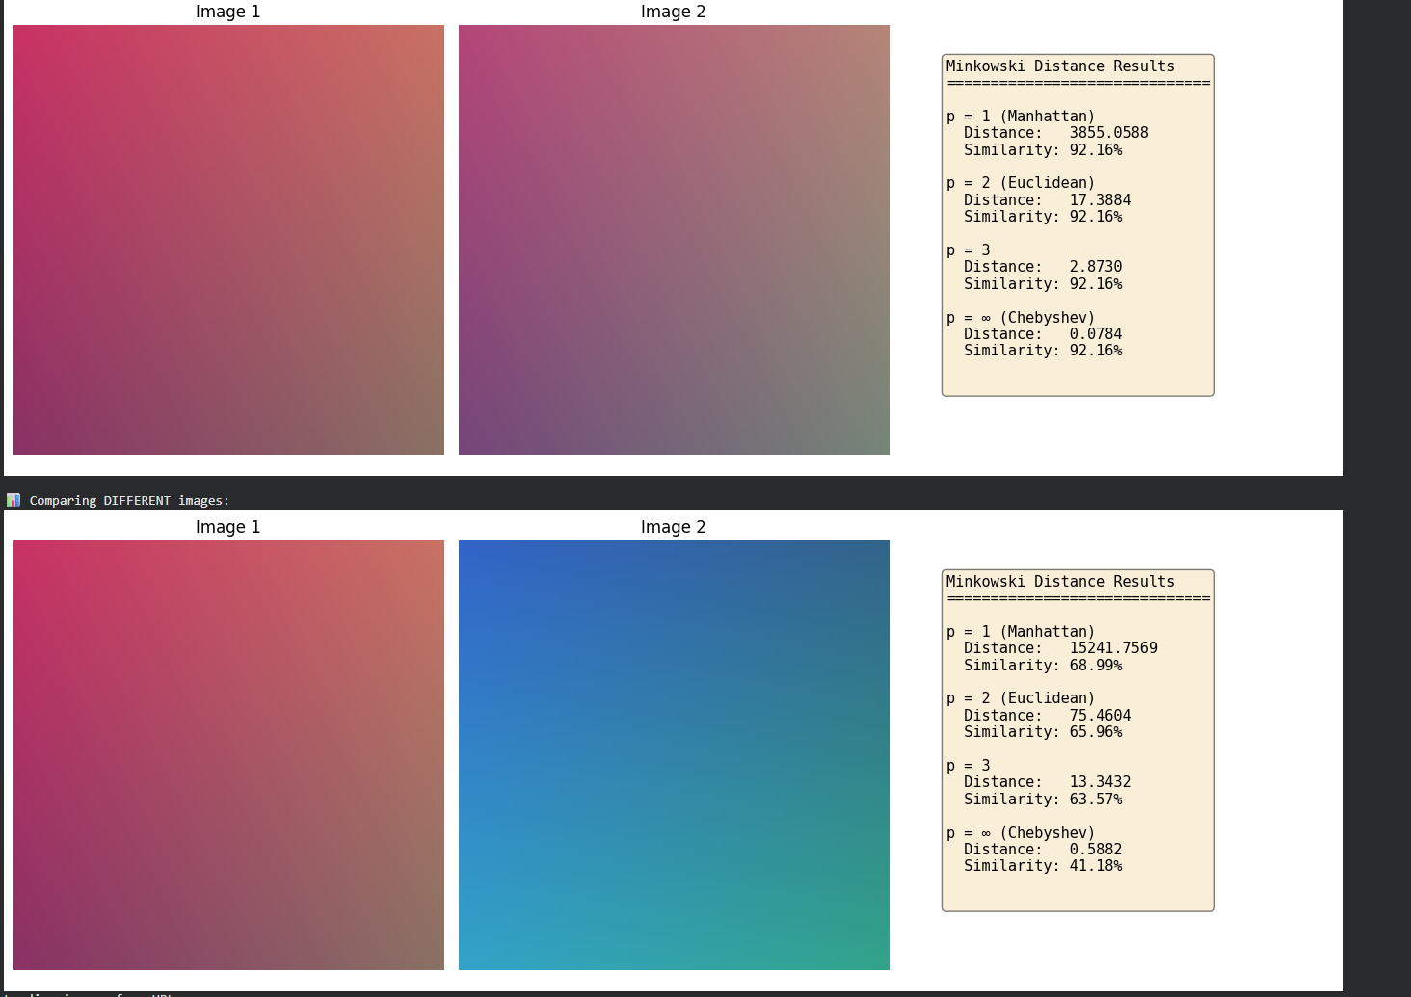
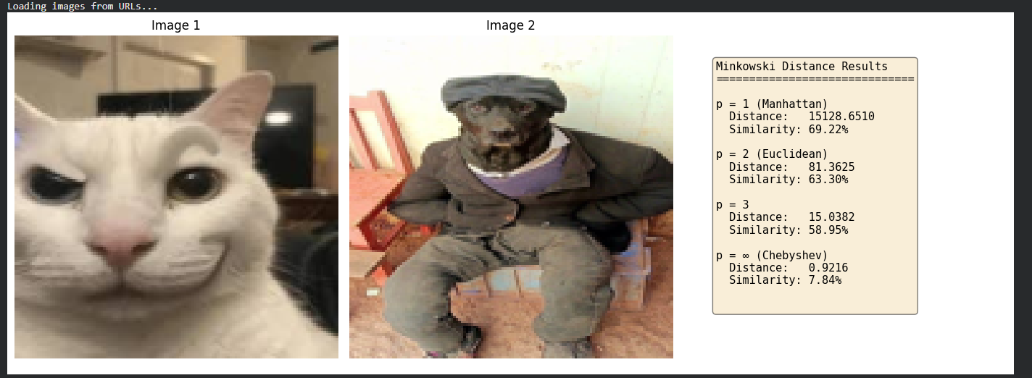

- Mahalanobis Distance

#Mahalanobis Distance

import cv2
import numpy as np
from scipy.spatial import distance

def load_image(path, size=(100, 100)):
img = cv2.imread(path)
img = cv2.resize(img, size)
img = cv2.cvtColor(img, cv2.COLOR_BGR2GRAY)
return img.flatten()

img1 = load_image('image1.jpg')
img2 = load_image('image2.jpg')

data = np.vstack([img1, img2])

cov_matrix = np.cov(data, rowvar=False)

cov_matrix += np.eye(cov_matrix.shape[0]) * 1e-5

inv_cov_matrix = np.linalg.inv(cov_matrix)

dist = distance.mahalanobis(img1, img2, inv_cov_matrix)

print("Mahalanobis Distance:", dist)

if dist < 10:
print("Images are similar")
else:
print("Images are different")

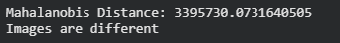

- Canberra Distance

#Canberra Distance

import cv2
import numpy as np
from scipy.spatial import distance

def load_image(path, size=(100, 100)):
img = cv2.imread(path)
img = cv2.resize(img, size)
img = cv2.cvtColor(img, cv2.COLOR_BGR2GRAY)
return img.flatten().astype(float)

img1 = load_image('image1.jpg')
img2 = load_image('image2.jpg')

# Compute Canberra distance
dist = distance.canberra(img1, img2)

print("Canberra Distance:", dist)

# Interpretation
if dist < 100:
print("Images are similar")
else:
print("Images are different")



- Earth Mover Distance

#EMD

import cv2
import numpy as np

def get_signature(image_path):
img = cv2.imread(image_path)
img = cv2.cvtColor(img, cv2.COLOR_BGR2HSV)

hist = cv2.calcHist([img], [0, 1], None, [8, 8], [0, 180, 0, 256])

#Normalize histogram
hist = cv2.normalize(hist, hist).flatten()

#creating signature: (weight, x, y)
signature = []
index = 0
for i in range(8):
for j in range(8):
weight = hist[index]
signature.append([weight, float(i), float(j)])
index += 1

return np.array(signature, dtype=np.float32)

def compute_emd(img1_path, img2_path):
sig1 = get_signature(img1_path)
sig2 = get_signature(img2_path)

#computing EMD
emd_value, _, _ = cv2.EMD(sig1, sig2, cv2.DIST_L2)

return emd_value

img1 = "image1.jpg"
img2 = "image2.jpg"

emd_score = compute_emd(img1, img2)
print("EMD Similarity Score:", emd_score)


- Quadratic Form Distance

#QFD

import cv2
import numpy as np

def get_histogram(image_path):
img = cv2.imread(image_path)
img = cv2.cvtColor(img, cv2.COLOR_BGR2HSV)

hist = cv2.calcHist([img], [0, 1], None, [8, 8], [0, 180, 0, 256])
hist = cv2.normalize(hist, hist).flatten()
return hist

def compute_similarity_matrix(num_bins):
A = np.zeros((num_bins, num_bins))

for i in range(num_bins):
for j in range(num_bins):
# Distance between bins
dist = abs(i - j)

A[i][j] = np.exp(-dist / 10.0)

return A

def quadratic_form_distance(hist1, hist2, A):
diff = hist1 - hist2
distance = np.sqrt(np.dot(np.dot(diff.T, A), diff))
return distance

img1 = "image1.jpg"
img2 = "image2.jpg"

h1 = get_histogram(img1)
h2 = get_histogram(img2)

A = compute_similarity_matrix(len(h1))
qfd = quadratic_form_distance(h1, h2, A)

print("Quadratic Form Distance:", qfd)

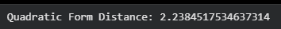

Q8. Given a confusion matrix
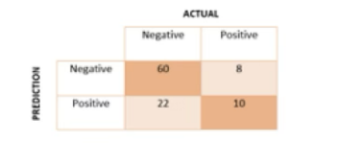
Write a program to find precision and recall, Average Precision, F-measure, Average Normalized Modified Retrieval Rank (ANMRR).

import numpy as np

#confusion matrix values
TP = 10
FP = 22
FN = 8
TN = 60

precision = TP / (TP + FP)
recall = TP / (TP + FN)
f1_score = 2 * precision * recall / (precision + recall)

average_precision = precision

relevant_ranks = [1, 3, 5, 7, 9] #hypothetical ranking positions
NG = len(relevant_ranks)
K = 2 * NG

avr = sum(relevant_ranks) / NG
mrr = avr / K
anmrr = 1 - mrr

print(f"Precision: {precision:.4f}")
print(f"Recall: {recall:.4f}")
print(f"F1-Score: {f1_score:.4f}")
print(f"Average Precision: {average_precision:.4f}")
print(f"ANMRR (approx): {anmrr:.4f}")

